**AIRLINE ANALYSIS Visualization with power bi and power query**

* Developed an airline analysis project leveraging Power BI, Power Query, and Power Pivot to analyze and visualize key metrics for the airline industry.
* "Performed data extraction, transformation, and loading (ETL) using Power Query to gather airline-related data from multiple sources."
* "Utilized Power Pivot to create a robust data model, incorporating various dimensions and measures for in-depth analysis."
* "Designed interactive visualizations and dashboards in Power BI, allowing stakeholders to explore and gain insights into airline performance, revenue, customer satisfaction, and operational efficiency."
* "Generated actionable reports and provided recommendations based on data-driven insights derived from the Power BI analysis.

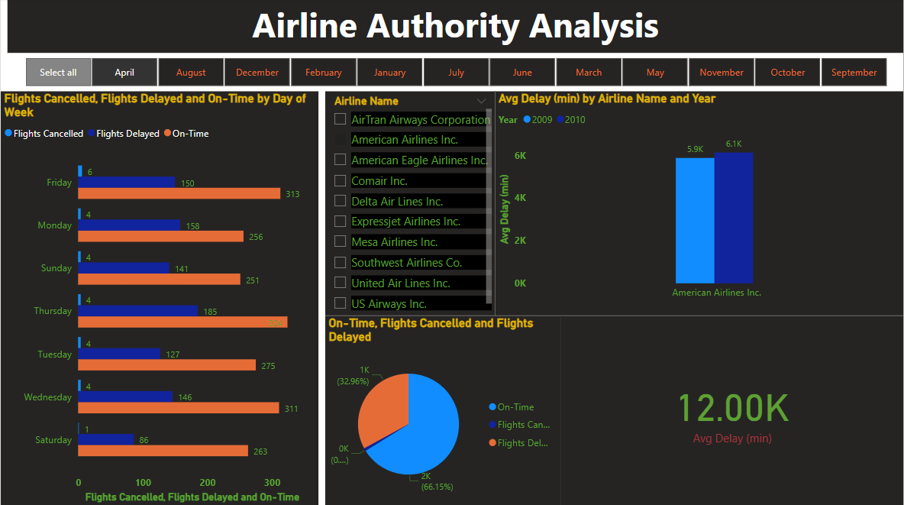**SNAPSHOTS**

